1. One customer calls the restaurant to make a reservation on Nov 20, 2 persons for dinner, the receptionist opens the reservation window, select date, time and size, then search for available tables.

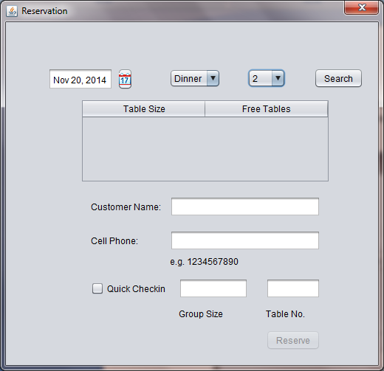

1. System displays all the available tables

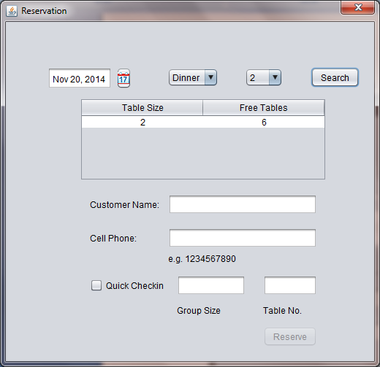

1. The receptionist selects one table, and enters user’s name and phone, clicks reserve button.

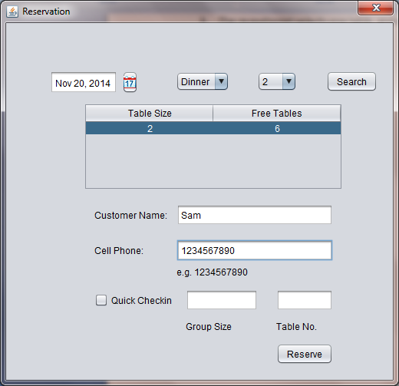

1. System pops out confirmation window to display reserving successfully.

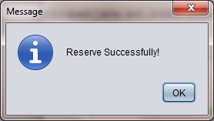

1. Click ok button, and close reservation window to return to main window.

